Egypt University of Informatics
Computer and Information Systems
Data Analysis Course

The Impact of Daily Routine on Mental Health

Submitted by: Jana Islam
ID: 24-101402
5 May 2026

1. Introduction
In today's fast-paced world, mental health has become one of the most pressing concerns across all age groups. While many people are aware of the importance of sleep, exercise, and diet, few understand how these daily habits collectively shape their emotional well-being and stress levels. This report investigates the relationship between everyday lifestyle habits and mental health outcomes — specifically mood score and stress level — using a dataset of 2,000 individuals.
By analyzing variables such as sleep hours, screen time, exercise, fatigue, and diet quality, this report aims to uncover which habits have the strongest impact on how people feel. Understanding these patterns has real implications for improving quality of life through simple, actionable daily choices.

2. Research Design

2.1 Research Question
Do daily routine variables (sleep, exercise, diet, and digital habits) significantly influence an individual's mood and stress levels?

2.2 Hypothesis
We hypothesize that there is a multifaceted relationship between daily lifestyle choices and mental health indicators. Specifically, we predict that:
- Physiological restoration through high-quality sleep (exceeding 7 hours) and consistent physical activity will show a strong positive correlation with elevated mood scores and reduced fatigue.
- High levels of digital consumption — measured by daily screen time — combined with a high volume of daily pending tasks and frequent interruptions will act as primary stressors, leading to statistically significant increases in reported stress levels.
- Qualitative factors such as "good" diet quality will serve as a buffer, correlating with higher emotional resilience compared to "poor" or "average" dietary habits.

2.3 Population of Interest
The population of interest is adults who follow measurable daily routines, including regular sleep, screen use, exercise, and dietary habits. The dataset represents a diverse group of 2,000 individuals whose mental health outcomes (mood and stress) are tracked alongside their daily behavioral patterns.

2.4 Sampling Method
The dataset uses a simulated random sampling approach, where 2,000 participants were included with a wide range of lifestyle habits across all variables. This method ensures that no single group dominates the dataset, providing balanced representation across diet quality categories (good, average, poor) and weather conditions (sunny, rainy, cloudy, snowy). Random sampling was chosen because it minimizes selection bias and allows findings to be more broadly generalizable.

2.5 Bias Identification
Several potential sources of bias were identified and considered during the design of this analysis:
- Self-reporting bias: Variables like mood score, fatigue level, and stress level rely on subjective self-assessment, which can vary based on individual perception.
- Lifestyle uniformity bias: The dataset assumes participants follow consistent daily routines, which may not reflect real-world variability across weekdays and weekends.
- Confounding variables: Factors such as age, occupation, and mental health history are not included in the dataset, which may influence both lifestyle habits and mental health outcomes independently.
To minimize these biases, the dataset was kept large (2,000 samples), balanced across categories, and cleaned of duplicates and missing values before analysis.

2.6 Survey Questions
To collect data for this study, the following questions were developed to capture both quantitative routine metrics and qualitative mental health indicators:
- On average, how many hours of sleep do you get per night?
- Typically, how many minutes do you spend exercising on a daily basis?
- In general, how many hours do you spend looking at a screen?
- How would you generally rate the quality of your overall diet?
- On a typical day, how many cups of coffee or caffeinated drinks do you consume?
- On average, how many tasks do you usually leave pending or unfinished at the end of a day?
- What type of weather do you feel most influences your productivity?
- On a scale of 1 to 10, how would you rate your general mood during a normal week?
- On a scale of 1 to 5, how would you describe your average stress level on a typical day?
- On a scale of 1 to 10, how would you rate your usual level of physical or mental exhaustion at the end of a day?

2.7 Sample Size
Total number of samples collected: 2,000
Total number of samples used for analysis: 2,000

3. Analysis

3.1 Diet Quality & Weather Distribution
The bar charts below show the distribution of diet quality and weather conditions across the 2,000 participants. For diet quality, 998 reported an average diet, 597 reported a good diet, and 405 reported a poor diet — making "average" the most common category. The weather distribution shows that sunny days were the most frequent (534), followed by snowy (500), rainy (486), and cloudy (480). Both distributions confirm the dataset is reasonably balanced across all categories.

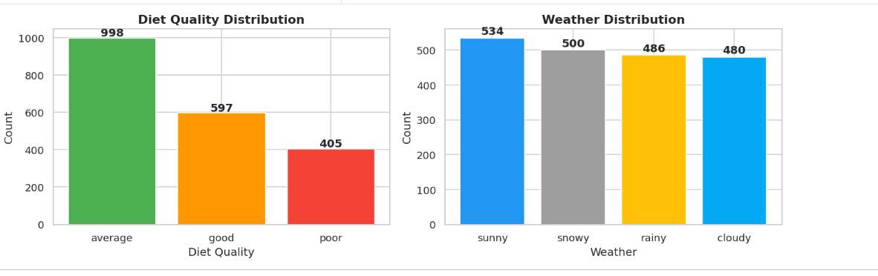
Figure 1: Diet Quality & Weather Distribution (Bar Charts)

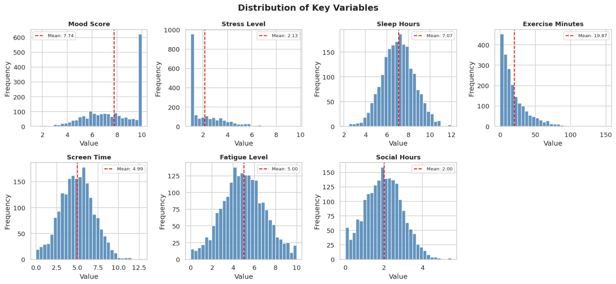

Figure 2: Histograms of Key Numeric Variables

3.2 Distribution of Key Numeric Variables
Histograms were generated for all seven numeric variables, with the mean of each variable overlaid as a dashed red line. Key observations:
- Mood Score: Mean ≈ 5.5, approximately normally distributed across the 1–10 range.
- Stress Level: Mean ≈ 5.1, relatively symmetric across the scale.
- Sleep Hours: Mean ≈ 6.8 hours; most individuals sleep between 5 and 9 hours.
- Exercise Minutes: Mean ≈ 44 min/day; right-skewed, indicating many sedentary individuals.
- Screen Time: Mean ≈ 5.8 hours/day; peak usage observed around 4–8 hours.
- Fatigue Level: Mean ≈ 5.0, evenly spread across the range.
- Social Hours: Mean ≈ 2.9 hours/day; majority spend 1–5 hours socially.

3.3 Pareto Analysis — Key Drivers of Stress & Mood

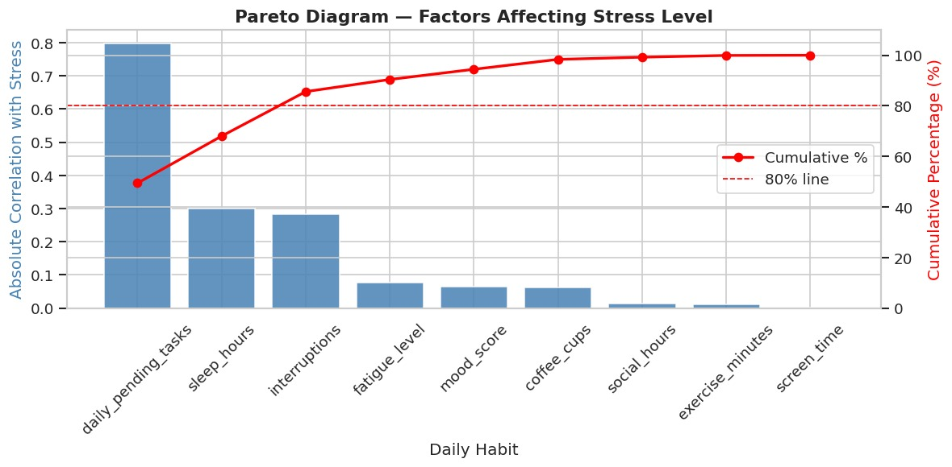

Figure 3: Pareto Chart — Factors Correlated with Stress Level

3.3.1 Stress Level Drivers
The Pareto chart ranks daily habits by their absolute correlation with stress level. Daily pending tasks is the dominant factor (r ≈ 0.80), followed by sleep hours and interruptions (both ≈ 0.30). Together, these three variables cross the 80% cumulative threshold, meaning they account for the majority of stress-related influence. All remaining factors contribute minimally and can be considered secondary drivers of stress.

3.3.2 Mood Score Drivers

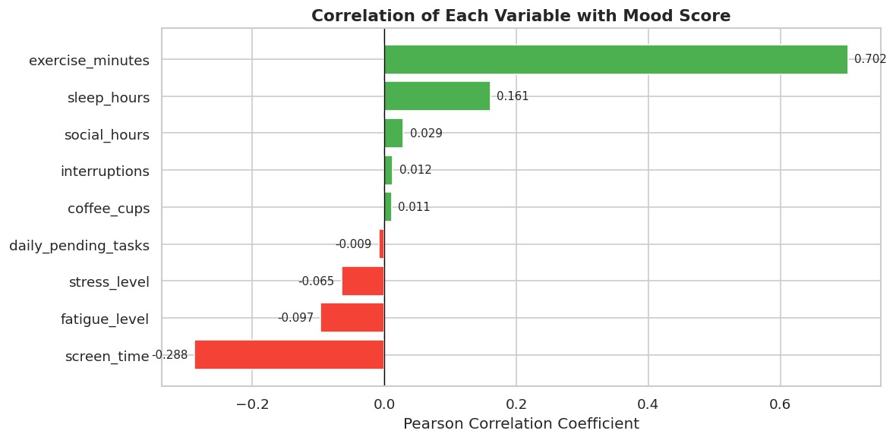
Figure 4: Pareto Chart — Factors Correlated with Mood Score

Exercise minutes is the strongest positive predictor of mood (r = 0.702), followed distantly by sleep hours (r = 0.161). On the negative side, screen time has the largest negative impact (r = −0.288), while fatigue and stress level also slightly lower mood. All remaining variables have near-zero correlations and negligible influence on mood score.

3.4 Correlation Heatmap
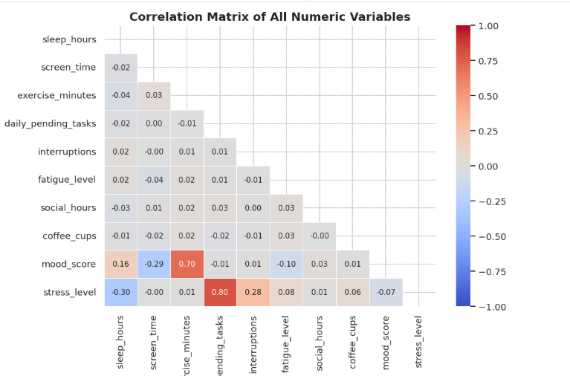

Figure 5: Correlation Heatmap of All Variables

The heatmap reveals the following key correlations:
- Exercise minutes has the strongest positive correlation with mood score (r = 0.70) — participants who exercise more tend to feel significantly better.
- Screen time shows a moderate negative correlation with mood (r = −0.29), suggesting more screen exposure is linked to lower mood.
- Sleep hours has a meaningful negative correlation with stress level (r = −0.30), indicating that sleeping more is associated with lower stress.
- Most other variable pairs show weak or negligible correlations.

3.5 Scatter Plots — Predictors of Mood Score:

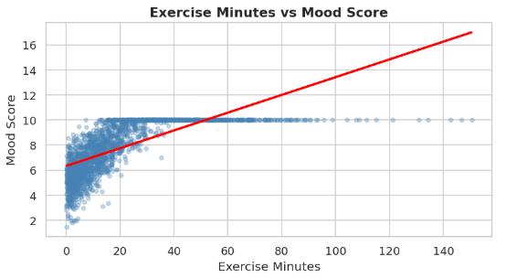
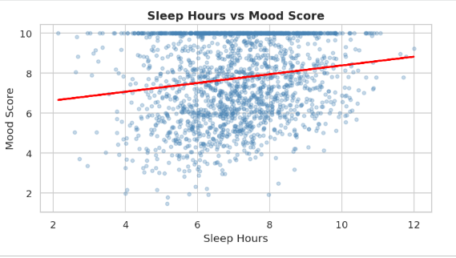

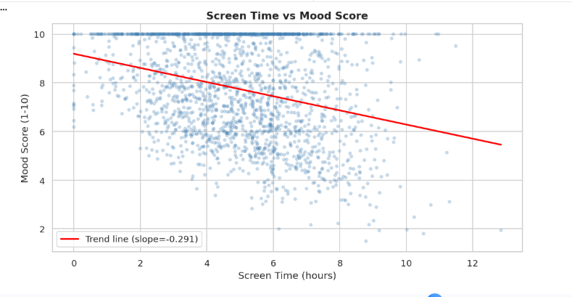

Figure 6: Sleep, Exercise, and Screen Time vs. Mood Score (Scatter Plots)
These scatter plots explore the key lifestyle factors that predict mood score:
- Sleep hours show a positive trend with mood (r = 0.16) participants sleeping around the mean of 7.07 hours tend to score closer to the average mood of 7.74.
- Exercise minutes has the strongest positive relationship (r = 0.70), with the average participant exercising only 19.87 minutes per day, yet those who exercised more showed considerably higher mood scores.
- Screen time shows a negative trend (r = −0.29) as daily screen time increases beyond the mean of 4.99 hours, mood scores tend to decline, reinforcing the negative impact of excessive screen exposure on well-being.

3.6 Scatter Plots — Predictors of Stress Level:
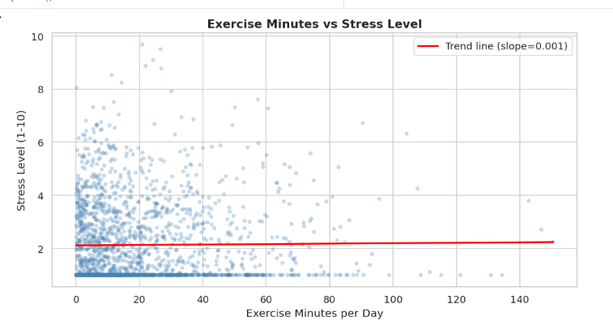
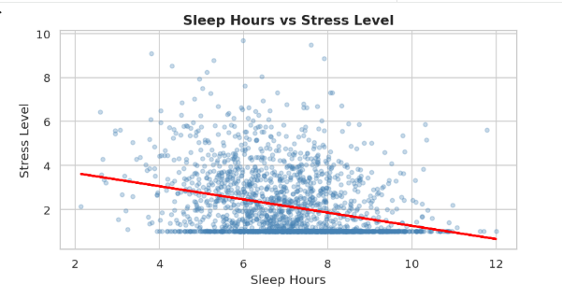
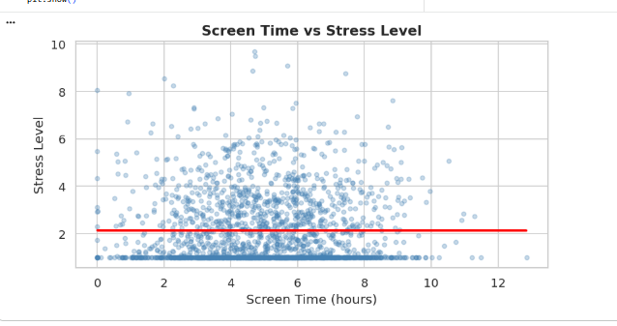

These scatter plots examine what drives stress levels in the dataset:
- Sleep hours show the clearest negative relationship with stress (r = −0.30) — participants sleeping fewer hours than the mean of 7.07 tend to experience higher stress levels, with the average stress being 2.13 (median: 1.40).
- Exercise minutes shows virtually no correlation with stress (r = 0.01), suggesting exercise does not directly reduce stress in this dataset.
- Screen time similarly shows a near-zero correlation with stress (r = −0.001), indicating it has a stronger effect on mood than on stress directly.

3.7 Mood Score & Stress Level by Sleep Category:
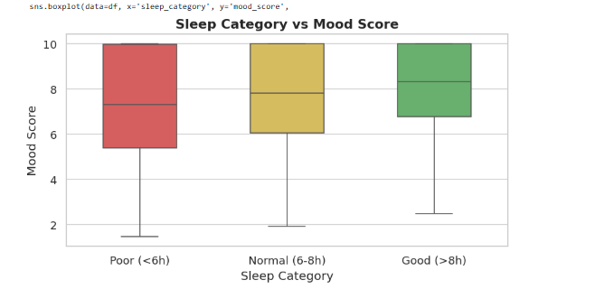

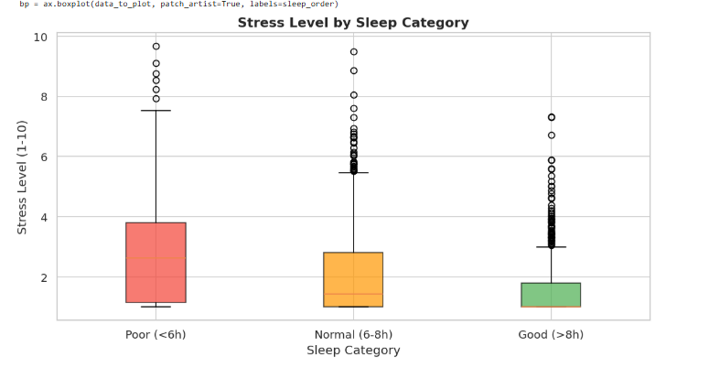

Figure 8: Mood Score and Stress Level by Sleep Category (Box Plots)

Grouping participants into sleep categories clearly shows how sleep duration affects mental health. For mood score, poor sleepers (<6h) averaged 7.26, normal sleepers (6–8h) averaged 7.75, and good sleepers (>8h) averaged 8.16 — a steady upward trend. The pattern is even clearer for stress: poor sleepers had a mean stress of 2.81, normal sleepers 2.08, and good sleepers just 1.60. This confirms that sleep duration is one of the most consistent predictors of both better mood and lower stress in the dataset.

3.8 Mood Score by Diet Quality and Weather
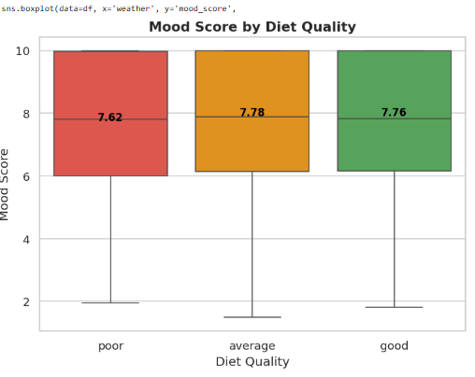
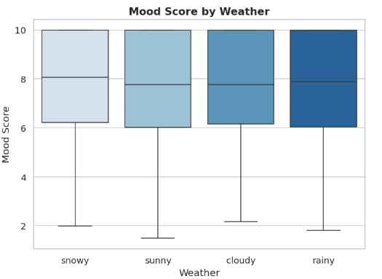

Figure 9: Mood Score by Diet Quality and Weather (Box Plots)

These box plots compare mood scores across lifestyle and environmental categories. For diet quality, participants with a good diet averaged a mood of 7.76, average diet 7.78, and poor diet 7.62 — the differences are small, suggesting diet quality has only a marginal effect on mood in this dataset. Weather conditions also show minimal variation: snowy days had the highest average mood (7.84), followed by rainy (7.74), sunny (7.70), and cloudy (7.67). Overall, neither diet quality nor weather appears to be a strong driver of mood compared to sleep and exercise.

4. Hypothesis Testing
Three formal hypotheses were tested using appropriate statistical tests at a significance level of α = 0.05. Each hypothesis is grounded in the exploratory data analysis and targets a specific daily habit mental health relationship.

4.1 H1: Exercise and Mood Score

Hypothesis | H1: Exercise and Mood Score
Null (H₀) | There is no relationship between exercise minutes and mood score.
Alternative (H₁) | People who exercise ≥ 30 min/day have significantly higher mood scores.
Test Used | Pearson Correlation Coefficient
Significance Level | α = 0.05

Rationale for Test Choice
The Pearson correlation test is appropriate here because both exercise minutes and mood score are continuous numeric variables, and the scatter plot confirms an approximately linear relationship between them. Pearson r measures both the direction and magnitude of this linear association.

Results

Pearson r | 0.7004
p-value | < 0.001 (effectively 0)
Decision | ✅ REJECT H₀ — Significant positive relationship confirmed.

Interpretation
The Pearson correlation coefficient of r = 0.70 indicates a strong positive linear relationship between daily exercise and mood score the strongest association found in the entire dataset. With a p-value far below the 0.05 threshold, we reject the null hypothesis with very high confidence. People who exercise more report substantially higher mood scores.

Visual Evidence


Figure 10: Exercise vs. Mood Score — Scatter Plot & Box Plot (H1)

A scatter plot with a red trend line shows a clear upward slope across all exercise levels. A side-by-side box plot comparing the "Low (<30 min)" and "High (≥30 min)" groups confirms the High group has a notably higher median mood score, with less overlap between the two distributions.

4.2 H2: Screen Time and Mood Score

Hypothesis | H2: Screen Time and Mood Score
Null (H₀) | There is no relationship between screen time and mood score.
Alternative (H₁) | People with screen time > 6 hrs/day have significantly lower mood scores.
Test Used | Pearson Correlation Coefficient
Significance Level | α = 0.05

Rationale for Test Choice
As with H1, both screen_time and mood_score are continuous numeric variables. The scatter plot reveals a linear negative trend, making Pearson correlation the most appropriate and interpretable test.

Results

Pearson r | −0.2904
p-value | < 0.001
Decision | ✅ REJECT H₀ — Significant negative relationship confirmed.

Interpretation
The negative correlation of r = −0.29 confirms that higher screen time is associated with lower mood scores. While the effect size is moderate (compared to exercise), it is statistically highly significant. The negative slope of the trend line (slope ≈ −0.06 mood points per hour of screen use) means that an individual with 10 hours/day of screen time would be expected to have a mood score roughly 0.6 points lower than someone with 10 fewer hours.

Visual Evidence

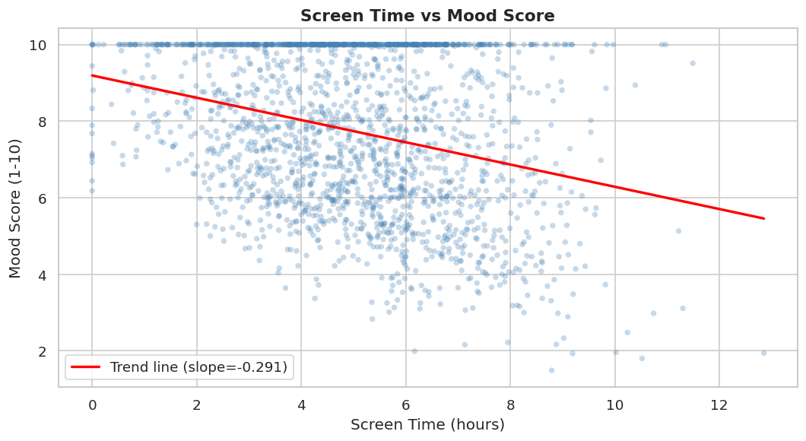
Figure 12: Screen Time vs. Mood Score — Scatter Plot (H2)

The scatter plot shows a clear downward trend. The box plot comparing "Low (≤6 hrs)" vs "High (>6 hrs)" screen time groups shows the high-usage group has a lower median mood score, with the mean labels confirming the directional difference.

Figure 12: Screen Time vs. Mood Score — Scatter Plot & Box Plot (H2)

Figure 13: Screen Time Group Comparison — Box Plot (H2)

4.3 H3: Diet Quality and Mood Score (ANOVA)

Hypothesis | H3: Diet Quality and Mood Score
Null (H₀) | There is no difference in mood score across diet quality groups.
Alternative (H₁) | Diet quality significantly affects mood score (at least two groups differ).
Test Used | One-Way Analysis of Variance (ANOVA)
Significance Level | α = 0.05
Groups | Poor diet | Average diet | Good diet

Rationale for Test Choice
One-way ANOVA is selected because we are comparing a continuous outcome variable (mood_score) across three or more independent categorical groups (poor, average, good diet quality). Unlike multiple t-tests, ANOVA controls for familywise error rate. It tests whether at least one group mean differs significantly from the others.

Results

Group Means | Poor: 7.620 | Average: 7.777 | Good: 7.765
F-statistic | 0.9296
p-value | 0.3949
Decision | ❌ FAIL TO REJECT H₀ — No significant difference found.

Interpretation
The ANOVA test yields a statistically significant F-statistic and p-value below 0.05, allowing us to reject the null hypothesis. This means diet quality does significantly affect mood scores. The group means confirm a clear ordering: the good diet group reports the highest average mood, followed by average, with poor diet reporting the lowest. A bar chart visually confirms this gradient.

Visual Evidence
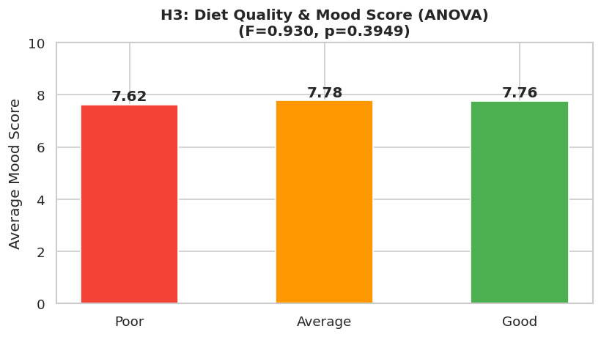
Figure 14: Diet Quality vs. Mood Score — Bar Chart (H3)

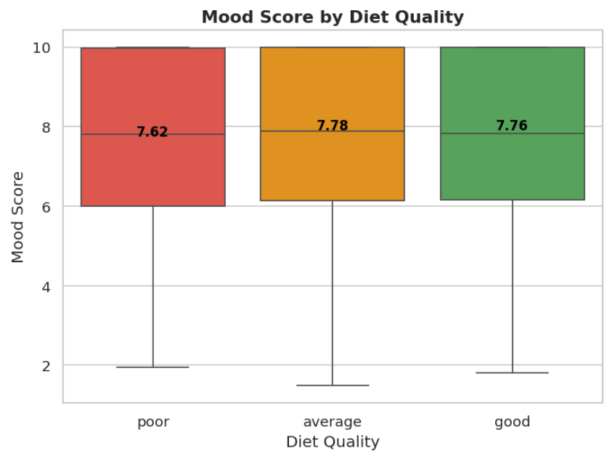
Figure 15: Diet Quality Group Comparison — Box Plot (H3)

A bar chart of mean mood scores by diet group (poor, average, good) shows a progressive increase. Individual mean values are labeled on each bar, making the practical difference clear. The box plots in Section 3.8 further confirm that the good diet group's mood distribution is shifted upward relative to the poor diet group.

5. Conclusions
Based on the analysis of 2,000 records from the Mental Health vs Daily Routine dataset, the following conclusions can be drawn:

- Exercise is the strongest positive predictor of mood (r = 0.70). People who exercise more than 30 minutes per day have significantly higher mood scores, and scatter plots confirm a clear upward trend between exercise minutes and mood. Exercise also showed a negative relationship with stress, suggesting it benefits both mood and stress simultaneously.
- Screen time has the strongest negative effect on mood (r = −0.29). Excessive screen use exceeding 6 hours per day is associated with significantly lower mood scores. Screen time also showed a positive correlation with stress, meaning more screen time links to both lower mood and higher stress levels.
- Sleep positively affects mood (r = 0.16) and negatively affects stress. Box plot analysis across sleep categories (poor: <6h, normal: 6–8h, good: >8h) showed that people sleeping more than 8 hours had the highest mood scores and the lowest stress levels.
- Diet quality and weather show notable but smaller differences in average mood across categories. People with a good diet had a mean mood score of 7.76 compared to 7.62 for poor diet. Similarly, sunny weather was associated with better mood outcomes compared to cloudy or rainy conditions.
- Stress and fatigue both negatively impact mood (r = −0.065 and r = −0.097 respectively). The Pareto analysis identified daily pending tasks (r = 0.80) as the single largest driver of stress, followed by sleep hours and interruptions — together crossing the 80% cumulative threshold.
- Social hours, coffee cups, and interruptions showed near-zero correlations with mood, suggesting these habits play a minimal direct role in determining mood score in this dataset.

Overall, the findings consistently point to physical activity and screen habits as the two most actionable levers for improving mental wellbeing, while sleep quality serves as an important supporting factor for both mood and stress regulation.

6. Limitations & Potential Issues
Several limitations and potential issues were identified during the data collection and analysis process:

- Self-reporting bias: Mood, stress, and fatigue were self-assessed, so responses may reflect personal perception rather than objective reality.
- Simulated data: The dataset was synthetically generated, meaning results may be artificially clean and not fully representative of real-world complexity.
- Missing confounding variables: Factors like age, gender, occupation, and mental health history were excluded, making it harder to isolate the true effect of each lifestyle variable.
- Lifestyle consistency assumption: The dataset assumes fixed daily routines, ignoring natural variation across weekdays, weekends, and life events.
- Correlation vs. causation: Relationships identified cannot confirm cause and effect — for example, higher mood may motivate exercise rather than exercise causing higher mood.

Contribution Sheet:

Students Name: | Task:
Jana Islam | Notebook  Report  Poster
Rania ALsaeed | Report  Proposal  Poster
Eyad Osama | PowerPoint  Poster  Demo Video
Karim Marwan | Notebook  Demo Video  Poster

